Name: **Slinky**

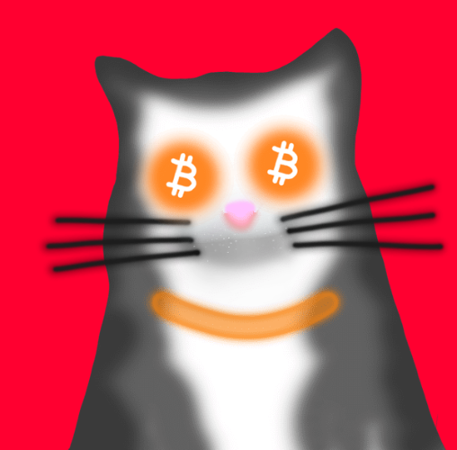

Name: **Gorda**

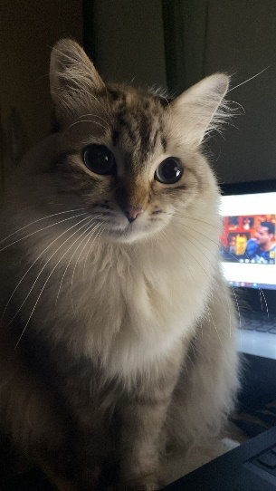

**What is OP_CAT:**

Created in 2009

It was the function used to create the first Bitcoin transaction to store data in satoshis in 2013, basically Erik Voorhees paid homage to his cat Mittens through the blockchain.

**How it works:**

Basically, the OP_CAT function is used to concatenate binary data, strings or bytes.

Therefore, if we apply the OP_CAT function in

push "Hello,"

push "World!"

OP_CAT "Hello, World"

**What happened to OP_CAT?**

The OP_CAT function was deactivated in 2010, due to memory problems that existed at the time.

**THE SAVIOR OF OP_CAT:**

In November 2021, with the Bitcoin Taproot update, OP_CAT was reactivated!

THEY ARE ALIVE!!

Taproot enabled a new way to encode bitcoin transactions. saving miners' memory usage, being more efficient.

**What is the importance of OP_CAT:**

OP_CAT was where the first registration of "Ordinals" on the bitcoin network began, it is what allows us to experience all this current movement, register, buy and sell "Ordinals" through the bitcoin network, the main savior was precisely TAPROOT!!!!